Info Capsule: Supporting Tools to Start Reflecting and Elaborating your Starting Point

When creating your starting point it is very important to take a personal snapshot on your teaching practice that could lead you to different personal learning goals during the whole reflective process. We can guide our personal process using different strategies, as for example:

-Defining specific personal learning goals whose level of achievement can be traced and analyzed in different moments of the process by the selected learning evidences.

-Defining personal learning needs by analyzing our previous teaching background and previous learning/teaching experiences. We can trace how these personal needs have been being met during the reflective process and which are the new learning needs that arise withing the CPD process.

-Defining initial main personal concepts, assumptions and beliefs regarding the profession of teaching as a foreign language that will be evolving, will be modified or reconceptualized by the new professional knowledge acquired during the reflective process.

-Describing our own teaching competences or skills at the initial moment of the process and comparing them with teaching competences and skills acquired in different moments of the process, as showed in the selected learning evidences.

In principle there is not a standards framework that is neccessary in order to stablish your own first snapshot as a teacher and to start developing your learning journey. However, here you can find some tools that can help you to first orientate yourself if you feel yourself a bit lost on stablishing specific development goals and a CPD action plan.

EPOSTL: European portfolio for Students teachers of languages

It is addressed to preservice teachers of foreign languages in initial teacher education. This guide helps student teachers to start reflecting on personal teaching competences by self-assessment can-do statement scales. They are distributed in different content areas: Context, Methodology, Resources, Lesson Planning, Conducting a Lesson, Independent Learning and Assessment of Learning.

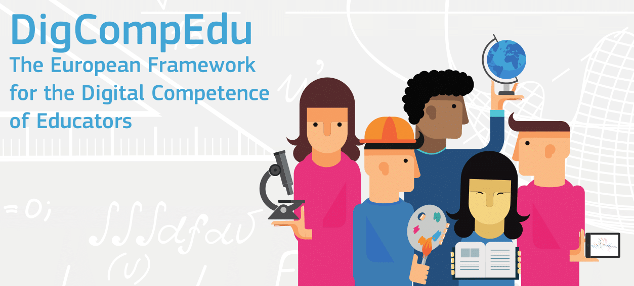 | DigCompEdu: European Framework for the digital Competences of Educators  This framework is addressed to preservice and in-service teachers for all subjects that want to reflect on and develop digital teaching competences. It helps you to identify yourself at a specific level of development in digital teaching competences and reflect about them by can-do statements related with the following areas:  Professional Engagement, Digital Resources, Teaching and Learning, Assessment, Empowering learners, Facilitating Learner Digital Competences.
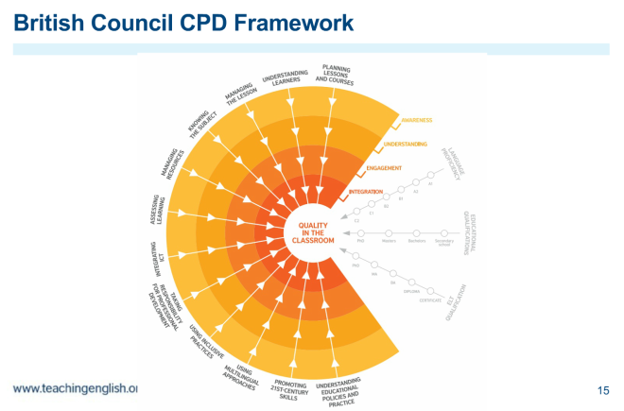 | British Council CPD Framework for Teachers  This tool is addressed to in-service teachers that want to make a CPD plan based on personal development on professional practices. The framework describes diverse professional practice areas and provide examples of good practices or activities.

From a Personal Snapshot to a CPD Plan to Elaborate your Starting Point

A CPD plan is a plan of actions that serves a teacher to develop his/her teaching competences and achieve his/her development goals. This prompts can help you to organize it.

  - Goals: Are the goals specific/measurable? Would you propose another development goals regarding the same competences? Arethem for long term, short term or mid term? Which possible obstacle/dificulties can you expect?

  - Strengths: Why do you consider these competences important? How can the strengths be used in her teaching experiences? Do you think about any other good practice examples?

  - Development areas: According to you, which actions can be done to develop these competences? How can be they assessed?Can you add any other good practice that can be helpful?

