Extra tutorial: Personalizing the privacy settings on your ePortfolio to make it accessible to different readers

During the process of elaboration of your ePortfolio, it will be open for different kind of readers (mentors, classmates, lecturers, practicum tutors or colleagues) who can read it and leave you different kinds of feedback or comments. Therefore, it is important to consider the different possibilities we have to make our ePortfolio accessible a readable. We can decide to keep it open to a general audience with public access, or we can decide to maintain certain pages or posts whereas another ones remain hidden. Some platforms give the option to access your ePortfolio by a specific password or just share it with specific contacts.

Let’s see how these privacy settings work in a website and in a blog (Google Sites and Blogger). Consider these options according to the readers you want to make it accessible within the different moments and steps of the elaboration of your ePortfolio.

Privacy settings in Google Sites

Firslty, as you know, in the working/draft space of your ePortfolio you can add, delete, modify and make any kind of changes. However in order to make your page available the first time, it is neccessary to click on the button Publish, on the right up bar of the site. All the modifications and changes performed after the first publishing of your site will only be saved and made available only clicking again the button Publish. Make sure, after have been working on your ePortfolio and you are sure you want to show them in your website that you click on the button Publish at the end of your work.

In this bar you can do and undo actions, as well as checking a preview of your site in different modes, as mobile or desktop. This is useful before publishing our work.

With the icon Share with others 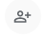 we can check the privacy and accessibility setting of our eportfolio:

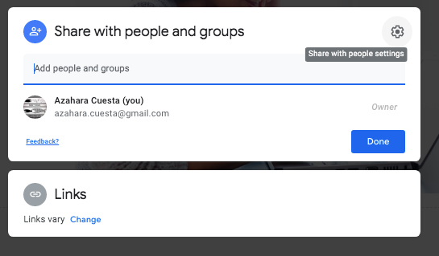

You have two options for sharing:

1. Sharing your ePortfolio with specific people or contacts. You can add the emails of these persons and give these contacts (or not) different roles in the elaboration of your site. If you want to make them collaborators of your website and allow them to edit your site, publish and save changes, change permissions and dd new people to your site, you can tick the box in the Share with people settings 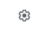
This can be useful if we want to invite some classmates or colleagues to collaborate with us, if we are doing a collaborative site. Or if we just want to invite others to read our website and leave us comments or feedback in a specific space (we can create a specific page in our website where these feedback and comments can be left).

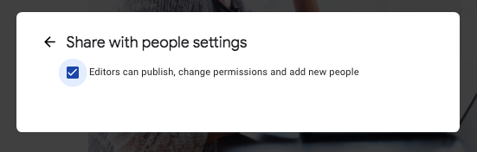

If you want to be the only owner and editor of your site and you just want to invite people to view the working space of your site and make some feedback or comments by other way (email, or separate document), just tick off this box.

2. Sharing by link: You can share the link with people with different privacy settings.

You can share your draft (working version of your ePortfolio) in a restricted way (only people with this link can edit to your site) or you can make your draft public (anyone in the Internet with this link can edit your site).

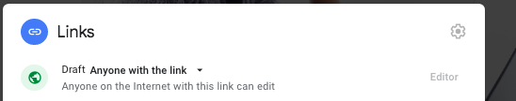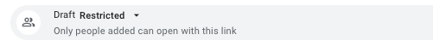

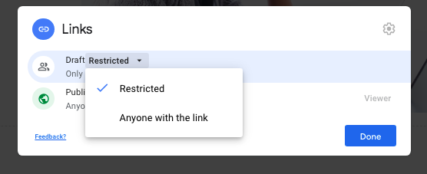

You can share your published site (public version of your ePortfolio) in an open way (anyone on the internet can find your site and open it) or a restricted way (only people added by you can open your site with this link).

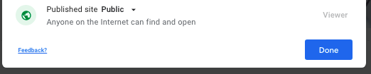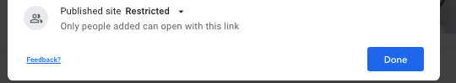

4. Apart of these general access setting to your eportfolio, Google allows you to hide or show the different pages of your website. This can be helpful if you want to make available just specific parts of your eportfolio to a reader and keep the rest accessible just for you or another mentors of your general ePortfolio. For example, if you would like to give access to a single entry to a lecturer that want to evaluate it, or a classmate that you want to give you feedback on a specific part of your site and you prefer to keep the rest of the entries for yourself.

Just go the Pages section on the side bar of the draft or working version of your eportfolio. You will see the index of the pages of your site

Cliking on the side icon of the page title click on Hide from navigation.
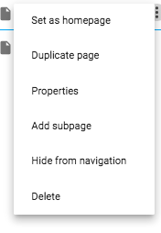
Then the page will be automaticly hidden. If you want to make accessible the page again, just click on the same icon and click on Show in navigation. 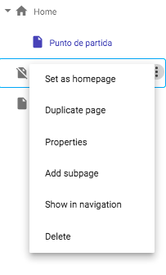

Privacy settings in Blogger

Although in a predetermined way your blog is Public to the general audience, you have the option to change your settings to adjust the access of your blog to specific people.

In the main page of blogger go to the arrow icon on the up bar and select the blog you want to change the settings.

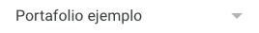

In the side bar, click on Settings and then go to the section Permissions<reader access.
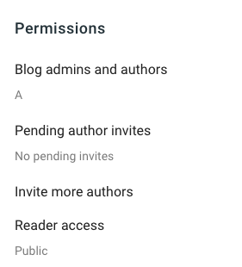

You can select if you want to keep your blog public, private to authors, or to select custom readers. Save the changes.
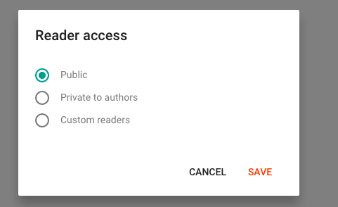

You can check more info about personalizing access and privacy settings on different website and blog platforms in the following links:

Wix

Weebly

WordPress

